
Company
Logotype

Cone Beam Computed Tomography- Report



Porur Dental X-rays & CBCT

Patient Name : Mr. Raghunath | Date of Report : 06.06.2024
Age/ Gender : 29 years/ Male | Region of Interest : CBCT Mandible
Referring doctor: Dr. Balamurali Sai | Indication : Impacted tooth
Clinical Notes: Nil
PATIENT INFORMATION

CBCT- Mandible provided
CBCT – IMAGE DETAILS

RADIOGRAPHIC INTERPRETATION

- The long axis of 38 and 48 appears to be parallel to the long axis of the adjacent teeth 37 and 47 respectively.
- The crown of 48 is present partially within the ascending ramus of mandible.
- The alveolar bone distal to 38 and 48 is present with funnel shaped hypodensity extending from crown upto to the Cementoenamel junction of 38 and 48 respectively.
- Distance between the apical portion of 38 and the Inferior Alveolar nerve canal: distal root is in contact.
- Distance between the apical portion of 48 and the Inferior Alveolar nerve canal: 2.81 mm.
- In relation to the periapical aspect of 37 (mesial root) presence of a diffuse hyperdense sclerotic region involving the root tip is evident.

RADIOGRAPHIC IMPRESSION

- Partially impacted with pericoronitis: 38, 48.
- Idiopathic osteosclerosis: 37 region.

Kindly correlate with clinical findings


IMAGES FOR REFERENCE

RECONSTRUCTED PANORAMIC VIEW

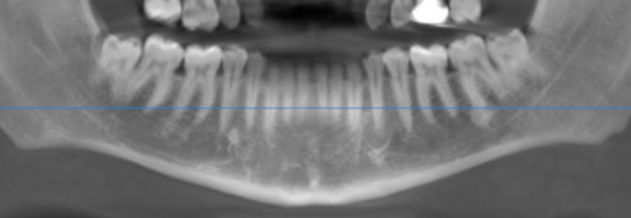

3-DIMENSIONAL VIEW

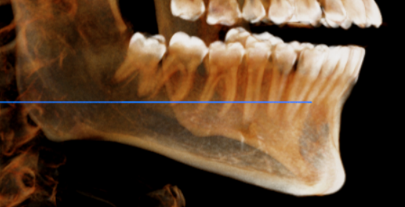
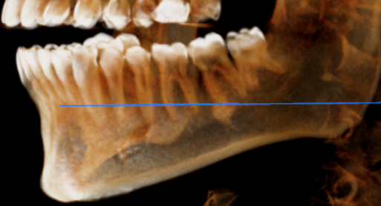

CROSS SECTIONAL VIEW

38 region- distal root is in contact with the inferior alveolar nerve canal | 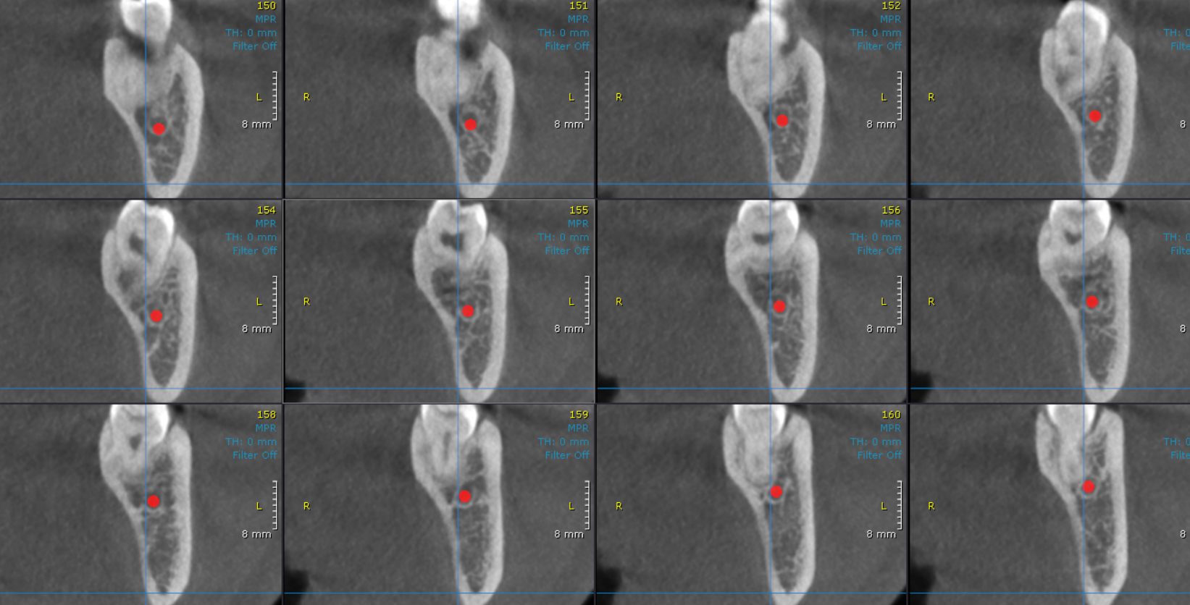
48 region | 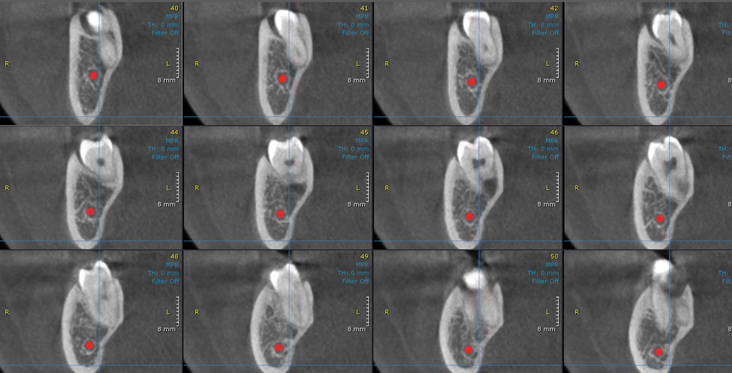

**** End of report ****

